Training regarding the groundwater modelling of Ezousa aquifer
Trainer: Constantinos F. Panagiotou, NIREAS (UCY)

Objective:
The aim of this training course is to develop a simple model that can be easily elaborated by the trainees. This model uses reasonable estimations for the hydraulic parameters (hydraulic conductivity, specific yield, specific storage), determined by calibrating other, more complete models.

Methodology:
The first step is to construct a base model. This model involves all physical processes that are commonly assumed to affect the spatio-temporal evolution of the hydraulic head (water levels). These processes are taken into account either through boundary conditions, or as sink/source terms. Subsequently, we will consider three different scenarios that involve the impact that both climate changes (first two scenarios) and human activities (third scenario) have on the head distribution.

Numerical Conditions:

Time period:
We have decided to use a short time, mainly because:
- it is easier for the trainees to apply the changes needed for the different scenarios and
- it requires much less computational time to run the simulations

Hydraulic parameters:
Regarding the hydraulic conductivity $(m/s)$, we choose the zonal values obtained by calibrating a more complete model (not discussed here). Uniform values are chosen for the specific storage $(m^{-1})$ and the specific yield (-), in accordance with existing reports.

Boundary conditions and sink/source terms:
We have considered the influence that the following processes have on the groundwater transport as follow:
- Coast: Acts as a physical barrier between the groundwater and the seawater. This term is treated as a constant head (CHD) boundary condition along the coastal line.
- Effective infiltration: This process refers to the combined action of precipitation, particularly rainfall, and evapotranspiration. This process is treated as a source term (RCH), expressed in $m/d$. The assigned values are uniformly distributed within the entire domain.
- Ambient groundwater: Refers to the groundwater entering the computational domain through its upper part. This process is treated as a constant head (CHD) boundary condition.
- Extraction wells: This process is treated as a sink term and it is applied at nine well locations (WEL). Thus, the assigned values are negative, expressed in ${m^{3}}/d$.
- Recharge ponds: Refers to the infiltration through the five complexes that contain infiltration ponds. This process is treated as a source term (RCH), expressed in $m/d$. Hence, the assigned values are always positive.

Scenarios

Base scenario

The base model contains all the major physical processes that characterise the aquifer state.
For the reasons previously mentioned, we choose a time period of one month. Since part of the available hydrological data are also collected in a monthly basis (e.g. extraction rates) we consider monthly averaged values for the different conditions (fixed during the period).

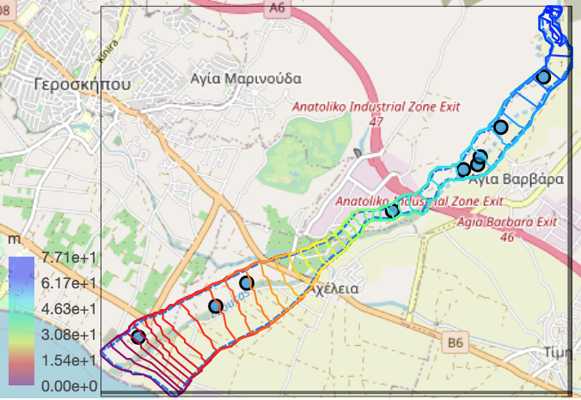
Figure 1: Head distribution at the end of the simulation period

Scenario 1: Variation on the effective infiltration

We conduct a sensitivity analysis in terms of the effective infiltration values. This scenario refers to the climate changes that are expected to become more intense in the upcoming years. We choose two different cases: (a) 10 times and (b) 1/10 the base value and (c) 100 times.

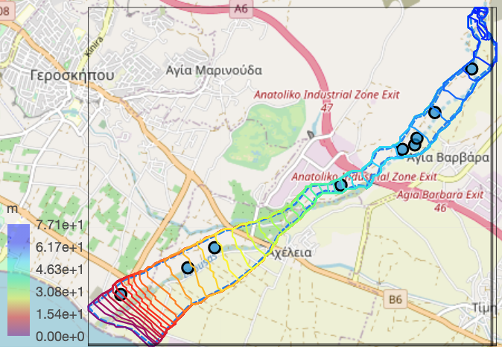 | 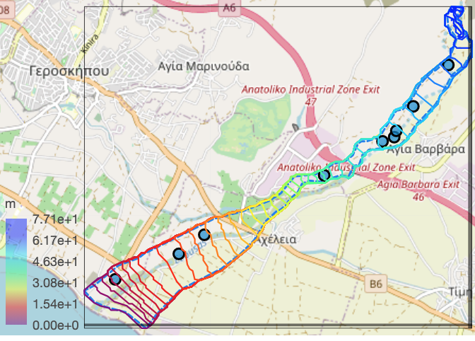
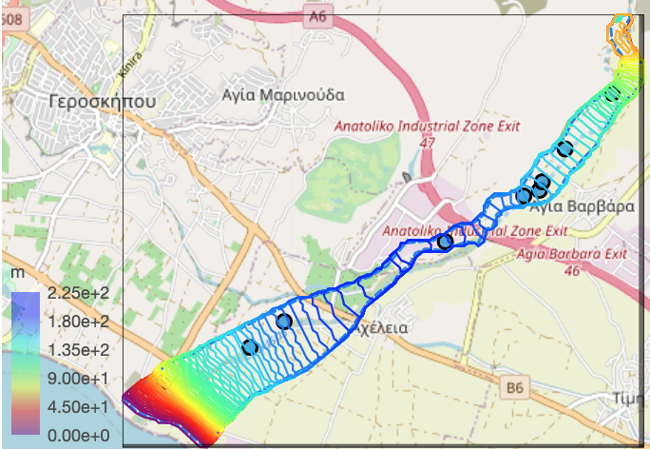
Figure 2: Head distribution at the end of the simulation period. Top Left: Scenario 1a. Top Right: Scenario 1b. Bottom: Scenario 1c

Scenario 2: Variation on the head levels of the riverbed.

Next, we consider the impact that different head levels of the riverbed can have on the groundwater movement. We choose to reduce the head levels along the riverbed by: 5 % of the base values.

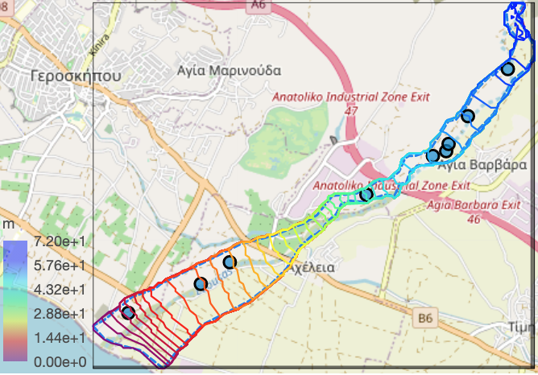
Figure 3: Left: Base model. Right: Scenario 2

Scenario 3: Reduction of the extraction rate at BH

The last scenario investigates the impact that the extraction rate at a specific well has on the groundwater system. We choose BH2978 because this is the major downstream well, corresponding to the highest amount of water extracted per year. We choose to (a) reduce the base value by 50 %, (b) increase it by a factor of 2 and (c) increase it by a factor of two while bringing it closer to the sea.

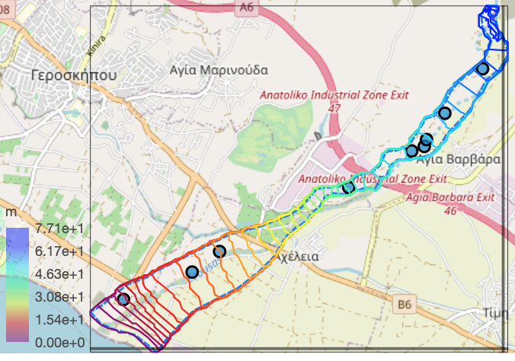 | 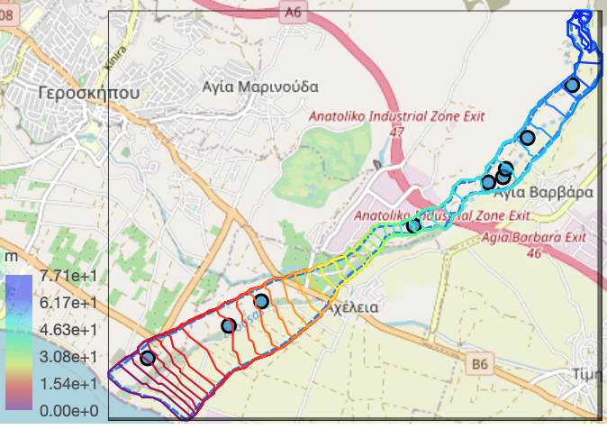
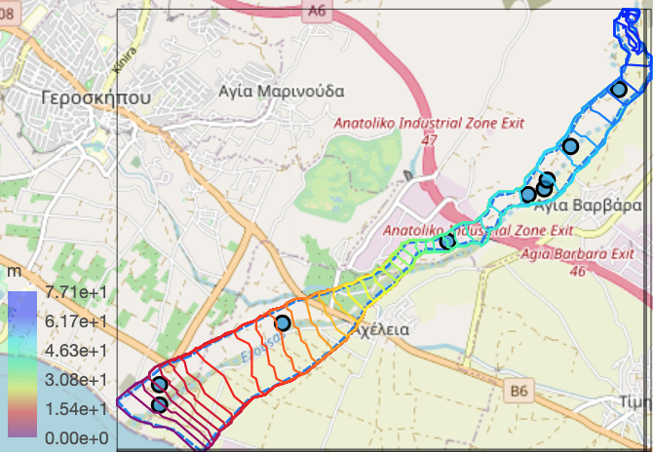
Figure 4: Head distribution at the end of the simulation period. Top Left: Scenario 3a. Top Right: Scenario 3b. Bottom: Scenario 3c

